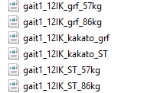

These are the settings file for external load and ground force. They are located at fullbody\static optimization tool

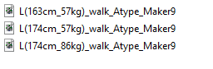

These are the model file I should use for my work. Marker 9 are the correct file in this folder

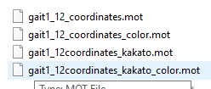

These are the motion files to be used with the models above. Here color means muscles are colored differently and kakato means ankle in Japanese.